Domain

Overview

Contents

Messaging 2
Quick Pitch 2
Top-line Benefits 2
Supporting Statistics 2
Detailed Benefits 3
Features 3
Customer Experience 3
Sales Support 5
Probing Questions 5
Selling Points 5
Competitive Information 5
Objection Handlers 5
Frequently Asked Questions 6

Messaging

Quick Pitch
A domain like www.domain.com is the address customers will use to find a business online. A custom domain is integral to a business because it establishes and strengthens brand identity. It’s the first step to getting set up online.

Think of a domain like a street address, just for the internet. A custom domain is the building block for a website and business class email.

A domain will differentiate a business from their competition. If the customer already have an existing domain, they can transfer it to us, keeping all their services in one place.

Top-line Benefits

Help the business get found online: A domain is the first step to having an online presence. It only grows from there.

Auto Renewal: Set the domain to automatically renew every year so your customer never has to worry about it expiring.

Simple Transfer: Transfer an existing domain for cost savings and to keep services all in one place.

Domain forwarding: Having multiple domains forward to the main domain will increase traffic to their site.

Establish brand identity: A domain allows your customer to have a name that potential and existing customers can use to find them online. Having a domain helps customers become more familiar with the business name.

Supporting Statistics

Having a domain with a country extension tells potential customers where the business is based in the world: 40% of all domains have country extensions (.uk, .cn, .de, etc.) (Domain wheel, 2023)
- Having an online presence leads to in person sales: 81% of internet users research products online before they make a purchase. (GE Capital Retail bank)
- Simplicity is key: The average domain name length of the five most popular websites is six characters. Shorter domains in general bring in more traffic. (Domain wheel, 2023)

Detailed Benefits

Establish brand identity | - Having a custom domain makes people remember a business and adds a layer of professionalism.
Builds Trust | - A branded domain builds trust with customers.
Control | - With our admin tools customers can manage the domain and choose where they decide to host the website and email
Save Money | - Our registration costs are competitive.
Many extensions | - Choose from many ext. such as .com, .ca, .net, .club, .org, .biz and more.
Competitive Pricing | - Annual terms of 1 year, 3 years and 5 years.

Features

Domain forwarding | - When customers have multiple domains forwarded to one domain this increases traffic to the main website.
Technical Support | - Technical support can assist with any issues that arise.
Simple Transfers | - Transfer an existing domain for cost savings easily.
Easy Management | - Manage domain settings in an easy-to-use online interface.
Domain privacy | - Protect personal data from being shared on the public domain registration site WhoIs

Customer Experience

When a customer purchases a domain, they will receive a welcome email with login credentials for the customer portal. It is an easy-to-use interface.

Once they login they can look under quick access and go to the domain manager.

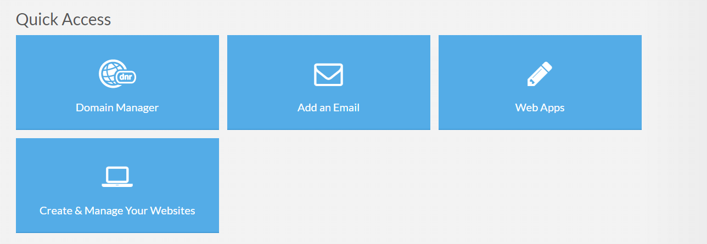

From there they can set up email, forwarding, modify name server settings, access the EPP code/password, update domain contacts, edit zone files, domain privacy and more.

They can also view the status of the domain, expiration date, auto-renewal and update name servers.

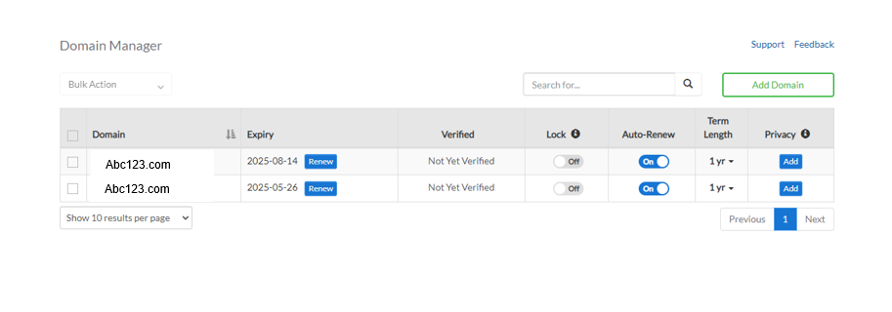
If they click on the domain it opens additional settings specific to that domain.
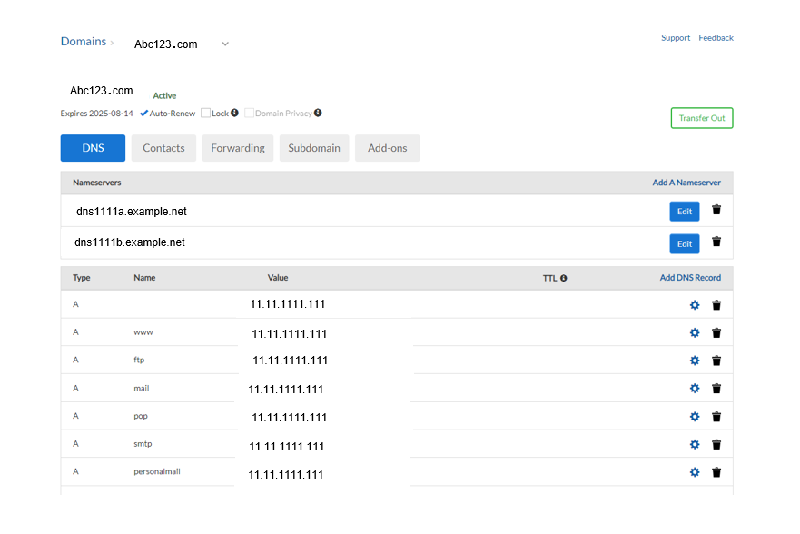

Sales Support

Probing Questions
Do you currently own a domain name?
Having a domain is the best way to start building your brand.

Have you considered purchasing an alternate domain to protect your brand’s identity?
You may want to secure the .com of your domain but consider purchasing the .net, and .org versions of your domain. If your domain has an uncommon spelling, consider purchasing the alternate spelling of your domain so potential customers can still find your business online.

Do you have control over your domain? Access to a tool to modify your domain settings?
With our domain manager you have complete control over your domain. You can access tools to modify your settings and set up forwarding, mail and more.

With your current provider, does the domain automatically renew?
Our domain services are able to be set to auto renew so you don’t have to remember to renew your domain yearly. This keeps your domain under your control so you have one less thing to worry about while running your business.

Selling Points
Stay engaged with your customers. By having a domain, you have more ways to connect with your customers and can build from there with a website and domain-based email.

Look credible and established. A domain makes businesses look established and make your customers want to do business with you. It should also tell your customer what type of business you are, so they can easily find your business while looking for your products/services.

Build trust. Having a domain helps your business look legitimate and it builds trust with your customer. Using the domain as a foundation, other services attached to your domain, like a website or domain-based email also help build trust.

Competitive Information
How does our domain service compare to others?

See Competitive Analysis

Objection Handlers
I don’t need one now; I can get it later.
Are you aware that domains are first come, first serve? A domain that is available now is not guaranteed to be available in the future.

I want to wait until I register my business with the government.
By secure the name now, you can use it when you’re ready. Registering your business with the government takes time and, in that time, your chosen domain could be registered by another business owner.

My business name might change.
If you have an idea of a multiple domain names, you can register several to make sure they are yours. When you do decide on the business name, you already have ownership of the domain, and can forward the others to the main domain, increasing traffic to your site.

I don’t want a website.
A domain is not the same as a website. Many business owners register multiple domain names (different spelling or different domain extensions) to protect the brand ensure no other businesses can register the name.

I am selling my business.
Having a domain means that your business holds the rights to that name. This can be part of the sale of your business and can be presented as a value add.

Frequently Asked Questions

What is a domain?
A domain name is an address that potential customers use to find your website. It will also be used to create business email addresses.

Do I own the domain or do you?
You own the domain. We register it and make sure you have access to the domain to set up a website, forwarding, mail etc.

What is WhoIs Record?
All registered domain names have a public record in the WhoIs database. It contains information on who owns the domain, the Registrar, domain status, initial registration date, expiration date and Name Servers. See: www.whois.com

How can I manage my domain?
When you purchase your domain, you will get access to a portal where you can login and select your services and then go to domain manager. From there you can view the status, expiration date, enable auto-renewal, update name servers, WhoIs Privacy settings, WhoIs contact information and get your EPP code.

How often do I pay for the domain?
Domains are renewed annually, for a minimum of one year and a maximum of ten years.

What is an EPP code and how do I access it?
An EPP or Extensible Provisioning Protocol is also called an authorization code. It is a secret and unique set of characters assigned by the domain registrar that is used to transfer a domain.

What is a zone file?
DNS zone files help in Domain Name System management. The files provide valuable information such as the email address of the admin, DNS records, the name servers involved and other additional information.

What is DNS?
DNS or Domain Name System is an internet protocol that distributes naming systems for computers, services and other resources on the internet. It is used to manage and map between names and numbers.

What is a name server?
A name server is a name in the DNS that translates domain names into IP addresses.

<< DOCUMENT END >>

